The Kingdom Parables V
“Parable of the Wedding Feast”
Mt. 22:2-14

Intro. – Review
- Main Topic_________________________________________________________________________.
- Progessive__________________________________________________________________________.
- Parable Means_______________________________________________________________________.
- Parables Explain_____________________________________________________________________.
- Number of Parables__________________________________________________________________.

I. Parable of the Wedding Feast
- Mt. 22:2-14
  - The Story
____________________________________________________________________________________________________________________________________________________________________________________________________________________________________________________________________________________________________________________________________________________________________________________________________________________________________________________________________________________

  - The Story Behind the Story
____________________________________________________________________________________________________________________________________________________________________________________________________________________________________________________________________________________________________________________________________________________________________________________________________________________________________________________________________________________

- This parable is really about______________________________________________________________
____________________________________________________________________________________________________________________________________________________________________________________________________________________________________________________________

- What we learn about the kingdom:
- The kingdom is like__________________________________________________________
__________________________________________________________________________

- God invited_________________________________________________________________
___________________________________________________________________________

- The rejection of the___________________________________________________________
______________________________________________________________________________________________________________________________________________________

- God sends His army__________________________________________________________
___________________________________________________________________________

- The king invites______________________________________________________________
___________________________________________________________________________

- The king provides____________________________________________________________
___________________________________________________________________________

- One guest enters, but__________________________________________________________
___________________________________________________________________________

- God will judge_______________________________________________________________
___________________________________________________________________________

- Many are___________________________________________________________________
___________________________________________________________________________

- Many are called_______________________________________________________________________
________________________________________________________________________________________________________________________________________________________________________

- If you answer_________________________________________________________________________
____________________________________________________________________________________

- If you don’t__________________________________________________________________________
____________________________________________________________________________________

- God chooses_________________________________________________________________________
________________________________________________________________________________________________________________________________________________________________________________________________________________________________________________________________________________________________________________________________________________

Summary

- The kingdom will be________________________________________________________________
________________________________________________________________________________.

- There will be a ____________________________________________________________________
__________________________________________________________________________________________________________________________________________________________________

- All are___________________________________________________________________________
_________________________________________________________________________________

- You must be______________________________________________________________________
__________________________________________________________________________________________________________________________________________________________________

- Those who refuse__________________________________________________________________
__________________________________________________________________________________________________________________________________________________________________

LITTLE LEARNERS
Matthew 22

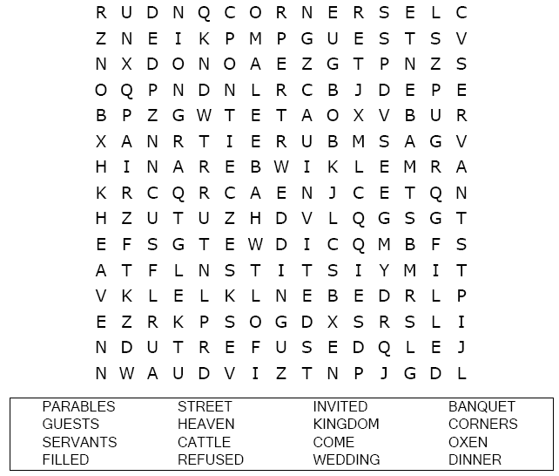  You are invited to the wedding banquet!  Can you find your way to the wedding cake?  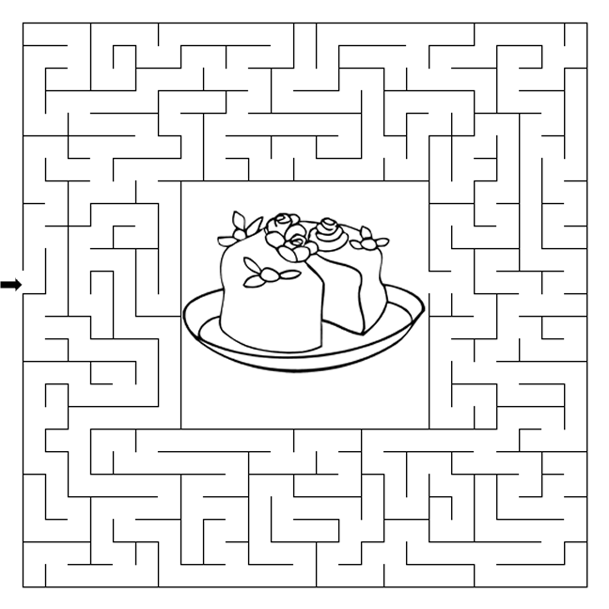 | Decoder Puzzle  Each number represents a letter of the alphabet. Substitute the correct letter for the numbers to reveal the coded words.  