LIFE LONG LEARNERS (adults)
Old Union Church of Christ

Darrell Duncan, associate minister
Matthew 25:14-30 Parable of the Talents

This is a Parable about P ____________ W _____________

Who are the Characters and Symbols in the story:

lord = Christ
Servants = Jesus’ disciples
Distribution of Talents = endowment of gifts, talents, responsibilities
Return of lord = 2nd coming of Christ
The accounting required = the Judgment
Profit reported = Improvement of gifts, talents
Joy of the lord = Heaven
Outer darkness = Hell
Faithful servants = Faithful Christians
Unfaithful Servants = Unfaithful Christians

What is the Lesson for us: ____________________________________________________________________________________________________________________________________________________________________________________________________________________________________

Matthew 25:31-46 Sheep and Goats

Remember the context here. It starts in Matthew 24 and is an ongoing conversation. They are interested in WHEN things will be happening, but Jesus is refocusing them on WHAT is important.

Why Sheep and Goats?

The bad/unrighteous | The Good/righteous
G O A T S   | S H E E P  
HELL | HEAVEN

WHO are the LEAST of these?
LITTLE LEARNERS
Matthew 25:14-46
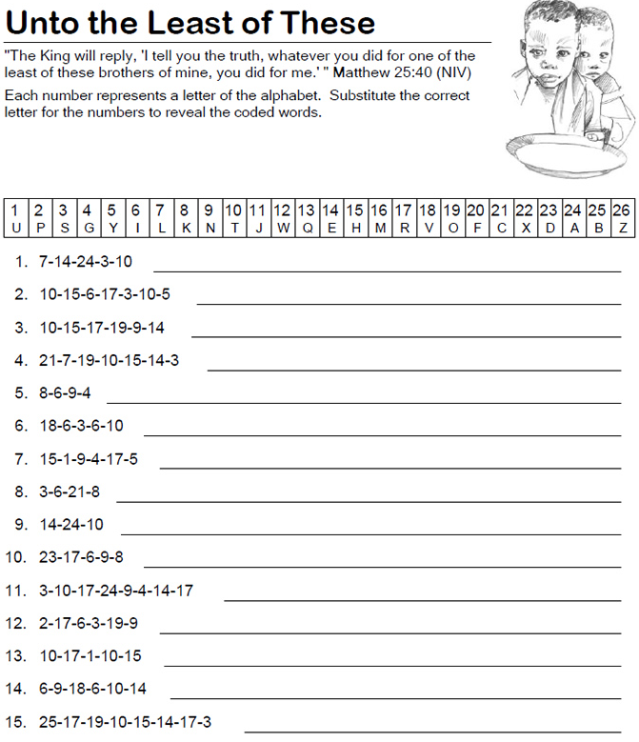 | 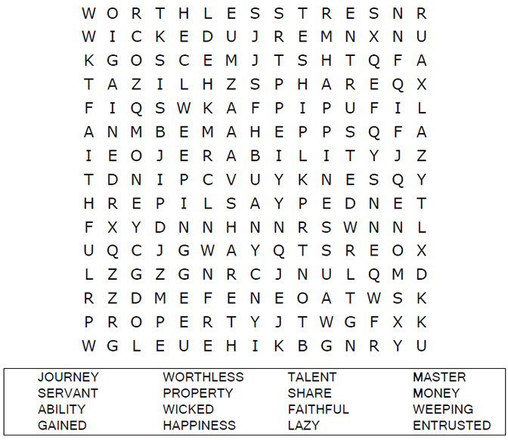
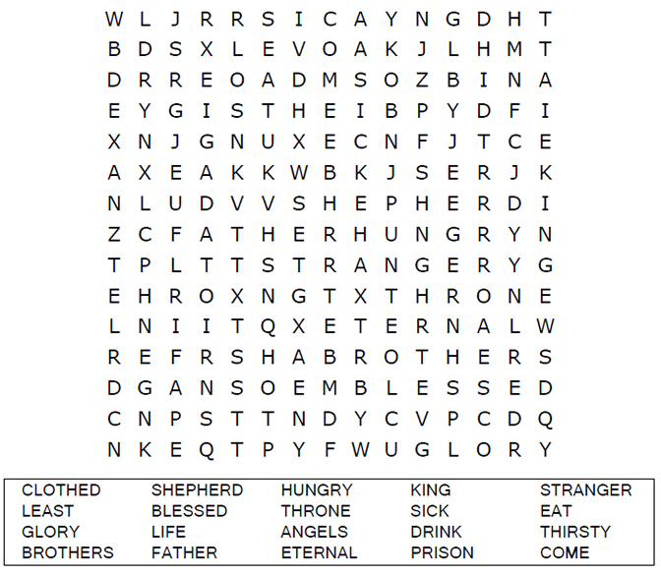 | 